OS LAB 3

22k-5195 Laiba Fatima

IN LAB:

1:

#!/bin/bash

# Log File Analyzer # Accept log file as input log_file="$1"

# Count total number of requests total_requests=$(wc -l < "$log_file") # Determine number of unique IP addresses

unique_ips=$(awk '{print $1}' "$log_file" | sort -u | wc -l)

# Identify top 5 most frequent IP addresses

top_ips=$(awk '{print $1}' "$log_file" | sort | uniq -c | sort -nr | head -5)

# Calculate total size of data transferred

total_size=$(awk '{sum += $10} END {print sum}' "$log_file")

# Generate summary report

echo "Log File Analysis Report" > analysis_report.txt echo "-------------------------" >> analysis_report.txt echo "Total Requests: $total_requests" >> analysis_report.txt echo "Unique IP Addresses: $unique_ips" >> analysis_report.txt echo "Top 5 IP Addresses:" >> analysis_report.txt echo "$top_ips" >> analysis_report.txt

echo "Total Size of Data Transferred: $total_size bytes" >> analysis_report.txt echo "Report generated on: $(date)" >> analysis_report.txt

OR

#!/bin/bash

# Check if the input log file is provided

if [ -z "$1" ]; then

echo "Usage: $0 <log_file>"

exit 1

fi

# Assign the input log file to a variable

logfile="$1"

# Count the total number of requests

total_requests=$(wc -l < "$logfile")

# Determine the number of unique IP addresses

unique_ips=$(awk '{print $1}' "$logfile" | sort | uniq | wc -l)

# Identify the top 5 most frequent IP addresses and their corresponding request counts

top_ips=$(awk '{print $1}' "$logfile" | sort | uniq -c | sort -rn | head -n 5)

# Calculate the total size of data transferred

total_size=$(awk '{sum+=$NF} END {print sum}' "$logfile")

# Generate a summary report

summary_report="Total requests: $total_requests\n"

summary_report+="Unique IP addresses: $unique_ips\n"

summary_report+="Top 5 most frequent IP addresses:\n$top_ips\n"

summary_report+="Total data transferred (in bytes): $total_size\n"

# Save the summary report to an output file

output_file="log_summary_report.txt"

echo -e "$summary_report" > "$output_file"

echo "Summary report generated: $output_file"

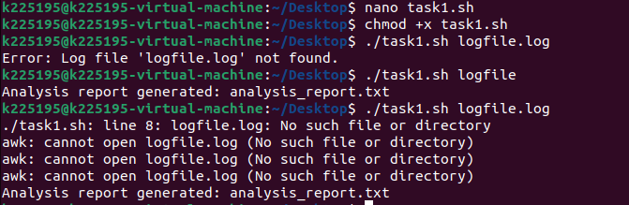

POST LAB:

1:

#!/bin/bash

directory_path="$1"

new_file_name_pattern="$2"

if [ ! -d "$directory_path" ]; then

echo "Error: Directory not found."

exit 1

fi

if [ -z "$(ls -A "$directory_path")" ]; then

echo "Error: Directory is empty."

exit 1

fi

if [ -z "$new_file_name_pattern" ]; then

echo "Error: Please provide a new file name pattern."

exit 1

fi

counter=1

for file in "$directory_path"/*; do

if [ -f "$file" ]; then

file_extension="${file##*.}"

new_file_name="${new_file_name_pattern}${counter}.${file_extension}"

mv "$file" "$directory_path/$new_file_name"

if [ $? -eq 0 ]; then

echo "Renamed '$file' to '$new_file_name'"

else

echo "Error: Failed to rename '$file'."

fi

((counter++))

fi

done

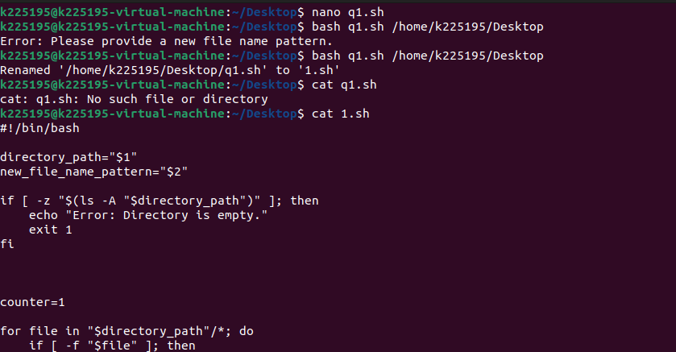

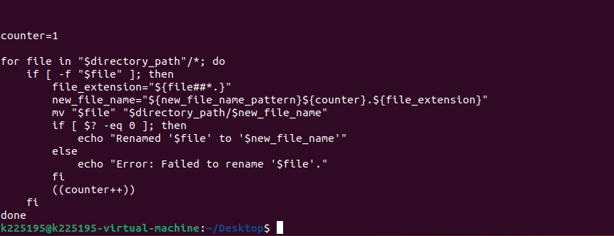

2:

#!/bin/bash

# Function to remove old files

remove_old_files() {

local directory="$1"

local days="$2"

local count=0

while IFS= read -r -d '' file; do

if [[ -f "$file" ]]; then

if [[ $(($(date +%s) - $(stat -c %Y "$file"))) -gt $((days * 86400)) ]]; then

rm "$file"

((count++))

fi

fi

done < <(find "$directory" -type f -print0)

echo "Removed $count files older than $days days."

}

# Function to remove empty directories recursively

remove_empty_directories() {

local directory="$1"

local count=0

while IFS= read -r -d '' dir; do

if [[ -d "$dir" && -z "$(ls -A "$dir")" ]]; then

rmdir "$dir"

((count++))

fi

done < <(find "$directory" -type d -print0)

echo "Removed $count empty directories."

}

# Main script

if [[ $# -ne 1 ]]; then

echo "Usage: $0 <directory>"

exit 1

fi

directory="$1"

if [[ ! -d "$directory" ]]; then

echo "Error: $directory is not a valid directory."

exit 1

fi

read -p "Enter the number of days to consider as old for files: " days

if [[ ! $days =~ ^[0-9]+$ ]]; then

echo "Error: Invalid input for days."

exit 1

fi

remove_old_files "$directory" "$days"

remove_empty_directories "$directory"

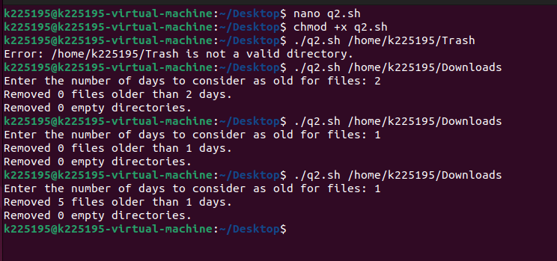

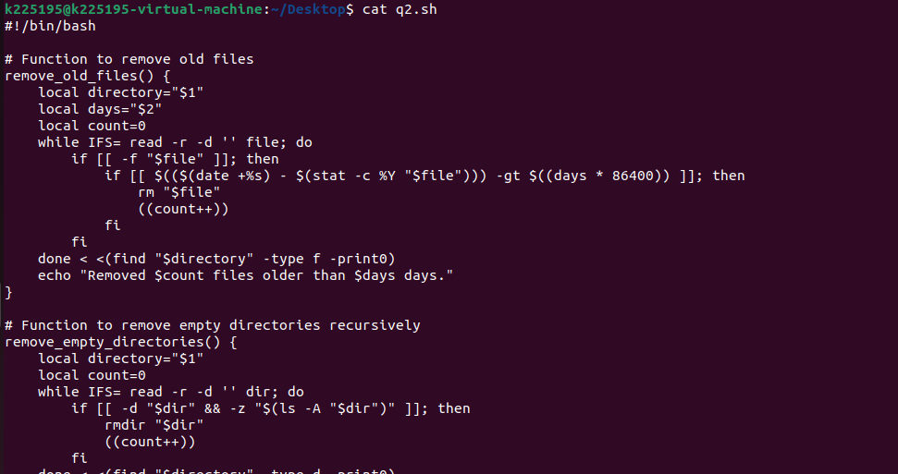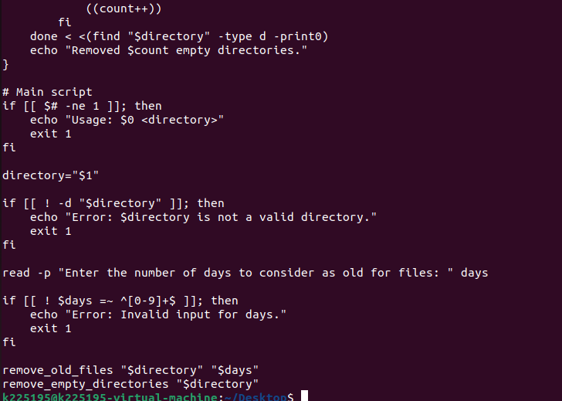

3:

#!/bin/bash

# Function to collect CPU usage

get_cpu_usage() {

cpu_usage=$(top -bn1 | grep "Cpu(s)" | sed "s/.*, *\([0-9.]*\)%* id.*/\1/" | awk '{print 100 - $1}')

echo "CPU Usage: $cpu_usage%"

}

# Function to collect memory usage

get_memory_usage() {

memory_usage=$(free | grep Mem | awk '{printf "%.2f", $3/$2 * 100}')

echo "Memory Usage: $memory_usage%"

}

# Function to collect disk space

get_disk_space() {

disk_space=$(df -h | awk '$NF=="/"{printf "Disk Usage: %s", $5}')

echo "$disk_space"

}

# Function to collect network traffic

get_network_traffic() {

network_traffic=$(ifstat 1 1 | awk 'NR==3{print "Incoming: " $6 " | Outgoing: " $8}')

echo "$network_traffic"

}

# Function to calculate average values

calculate_average() {

duration=$1

# Calculate average CPU usage

avg_cpu=$(top -bn$duration -d1 | grep "Cpu(s)" | tail -n$duration | awk '{total += (100 - $8)} END {print total/NR}')

# Calculate average memory usage

avg_memory=$(free -m | awk 'NR==2{total += $3} END {print total/NR}')

echo "Average CPU Usage (over $duration seconds): $avg_cpu%"

echo "Average Memory Usage (over $duration seconds): $avg_memory MB"

}

# Function to generate report

generate_report() {

report_file="system_report_$(date +'%Y-%m-%d_%H-%M-%S').txt"

echo "System Report" > "$report_file"

echo "------------------------" >> "$report_file"

get_cpu_usage >> "$report_file"

get_memory_usage >> "$report_file"

get_disk_space >> "$report_file"

get_network_traffic >> "$report_file"

calculate_average "$1" >> "$report_file"

echo "Report generated: $report_file"

}

# Main script

echo "System Monitoring Script"

echo "------------------------"

echo "1. Generate report"

echo "2. Exit"

read -p "Enter your choice: " choice

case $choice in

1)

read -p "Enter duration for average calculation (in seconds): " duration

generate_report "$duration"

;;

2)

echo "Exiting script."

exit 0

;;

*)

echo "Invalid choice. Exiting."

exit 1

;;

esac

